**Checking URL**

Step 1: Navigate to google chrome.

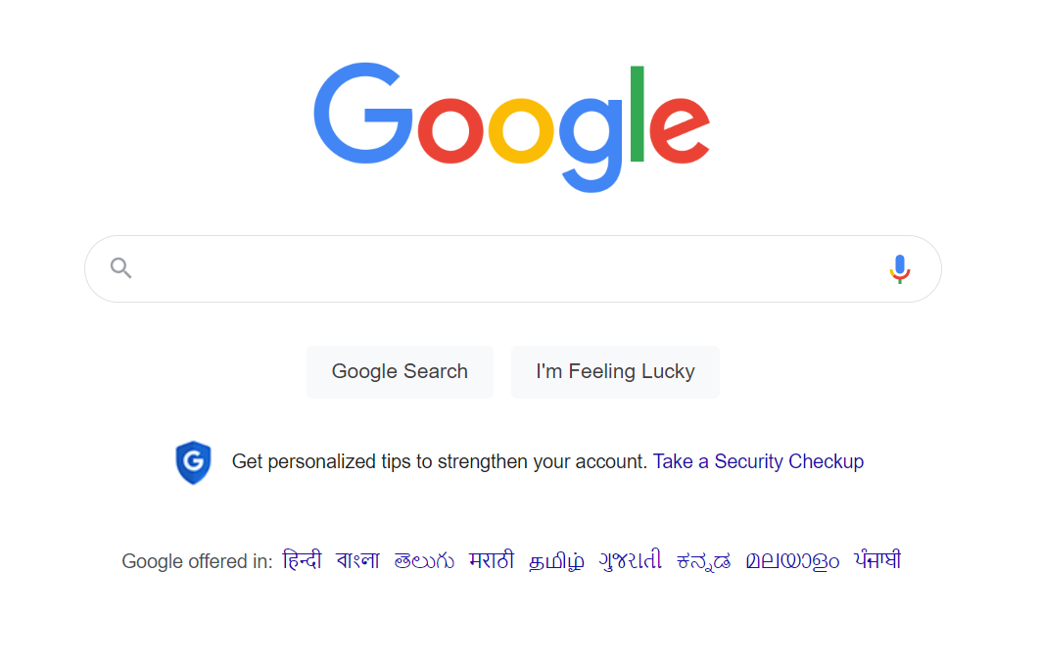

Step 2: Navigate to swag labs site using the URL- <https://www.saucedemo.com/>

